PERFORMANCE CALCULATOR | Level 1 |  |  | Level 2 |  |  | Level 3 |  |  | Level 4 |  |  | Level 5 |  |  | Level 6
A LEVEL PRACTICAL  – SEPT 2016 | LIMITED ABILITY |  |  | BASIC ABILITY |  |  | EMERGING COMPETENT ABILITY |  |  | COMPETENT AND CONSISTENT ABILITY |  |  | CONFIDENT AND ASSURED ABILITY |  |  | EXCEPTIONAL ABILITY
Taxonomy | partial, inconsistent, literal, elementary, minimal, rushed, sporadic, naïve, little creative intent, disjointed, pedestrian, credible, lacks control over the formal elements, vague aims |  |  | straightforward, deliberate, just adequate, methodical, superficial, unrefined, crude visual language, simplistic reflection, plays safe, unresolved, contextual references explored but lack relevance, defines aims with some understanding, developing control over the formal elements |  |  | predictable, broadening, makes progress, relevant, description not explanation, demonstrates intentions, appropriate, sufficient control, emerging individuality, thorough, adequate control over the formal elements, contextual references inform journey, pursues aims with understanding |  |  | diverse, effective, purposeful, consistent, skillful, coherent, imaginative, informed, some perception, satisfies creative intent, engaged, consistent control over the formal elements, contextual references inspire creativity, realises some aims, |  |  | independent, realised, sensitive, creative, sustained, highly inventive, critical, perceptive, comprehensive, in-depth, insightful, original, genuine creative journey, refined, in-depth reflection, exciting, comprehensive control over the formal elements, contextual references shows some personal insight, fully realises all aims and objectives |  |  | inspired, surprising, unique, authoritative, genuine discovery, adventurous, accepting of the unexpected, challenging, fully informed, questioning, dexterous, erudite, highly intuitive, daring, insightful and comprehensive exploration of contextual references, ideas synthesised into highly sophisticated realisations, goes beyond aims to produce surprising realisations, control over the formal elements demonstrate fluent sensitivity and understanding
AO1  Develop ideas through sustained and focused investigations informed by contextual and other sources, demonstrating analytical and critical understanding | 1 | 2 | 3 | 4 | 5 | 6 | 7 | 8 | 9 | 10 | 11 | 12 | 13 | 14 | 15 | 16 | 17 | 18 | AO1 total:
 | LIMITED |  |  | BASIC |  |  | EMERGING COMPETENT |  |  | COMPETENT AND CONSISTENT |  |  | CONFIDENT AND ASSURED |  |  | EXCEPTIONAL
AO2  Explore and select appropriate resources, media, materials, techniques and processes, reviewing and refining ideas as work develops | 1 | 2 | 3 | 4 | 5 | 6 | 7 | 8 | 9 | 10 | 11 | 12 | 13 | 14 | 15 | 16 | 17 | 18 | AO2 total:
 | LIMITED |  |  | BASIC |  |  | EMERGING COMPETENT |  |  | COMPETENT AND CONSISTENT |  |  | CONFIDENT AND ASSURED |  |  | EXCEPTIONAL
AO3  Record ideas, observations and insights relevant to intentions, reflecting critically on work and progress | 1 | 2 | 3 | 4 | 5 | 6 | 7 | 8 | 9 | 10 | 11 | 12 | 13 | 14 | 15 | 16 | 17 | 18 | AO3 total:
 | LIMITED |  |  | BASIC |  |  | EMERGING COMPETENT |  |  | COMPETENT AND CONSISTENT |  |  | CONFIDENT AND ASSURED |  |  | EXCEPTIONAL
AO4  Present a personal and meaningful response that realises intentions and, where appropriate, makes connections between visual and other elements | 1 | 2 | 3 | 4 | 5 | 6 | 7 | 8 | 9 | 10 | 11 | 12 | 13 | 14 | 15 | 16 | 17 | 18 | AO4 total:
 | LIMITED |  |  | BASIC |  |  | EMERGING COMPETENT |  |  | COMPETENT AND CONSISTENT |  |  | CONFIDENT AND ASSURED |  |  | EXCEPTIONAL
 |  |  |  |  |  |  |  |  |  |  |  |  |  |  |  |  |  |  | Total mark:
Using the performance calculators
All A level student work should be marked using the assessment grid in the accredited specification.
The performance calculators are a support tool to help you make accurate judgements about student work. There are two performance calculators:
- One for assessing A level practical work and written annotation
- One for assessing A level personal study
Step by step instructions
- Choose the relevant performance calculator.
- Take each Assessment Objective (AO) in turn.
- Follow the AO across the chart (from left to right) until the work exhibits characteristics reflected in the taxonomies in the levels from 1 to 6.
- Choose those taxonomy words that apply to the work (not all of them will) and write them in the appropriate box(es) on the performance calculator.
- Writing the taxonomy words in the relevant boxes will give you a clear visual picture (like a graph) of the student’s performance for each AO (see the worked example below).
- At any time, look at real student work that has been marked by our senior examiners. You can access real student work on our website.
- Circle the mark awarded or write the mark awarded in the far right-hand column.
A worked example
In AO1, an A level student may show superficial development and their analysis of other artists' work may be unrefined. They may show a lack of understanding, with simplistic reflection and unresolved connections to their resources. This would place this student firmly in the middle of Level 2 BASIC ABILITY. The student is solidly in this level, and would receive 5 marks for AO1.
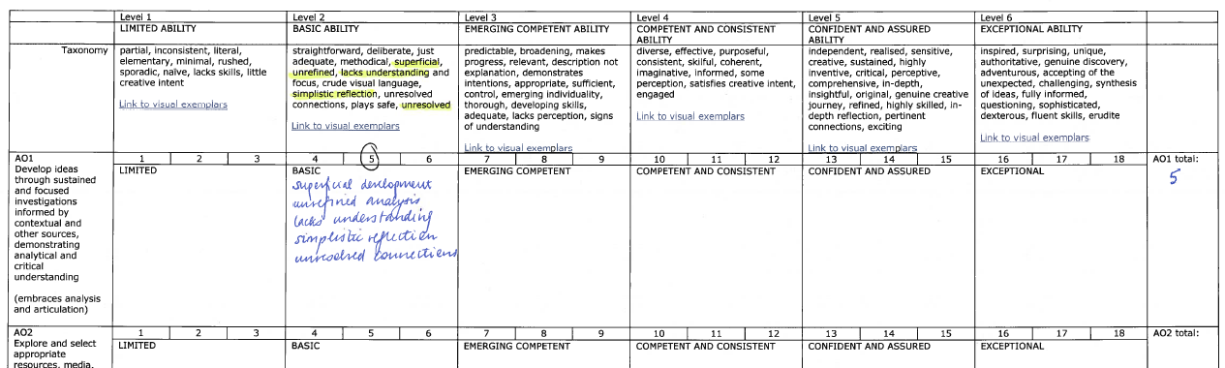
This same student might be showing broadening understanding of some of their contextual references. ‘Broadening’ is in the taxonomy of Level 3 EMERGING COMPETENT ABILITY. The fact that ‘broadening’ applies to the work pushes the student towards the next level. This would place the student at the top of Level 2 BASIC ABILITY so the student would receive 6 marks for AO1.
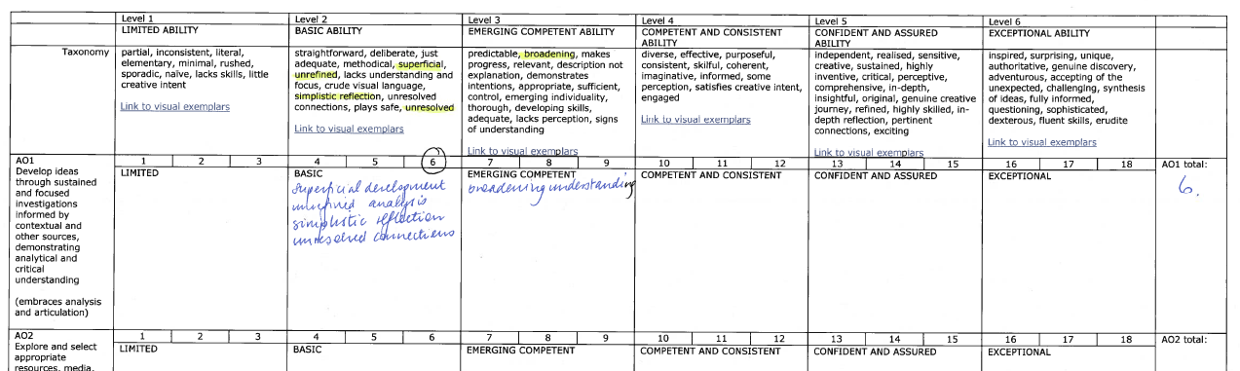

If the student achieves even more words in the higher level, they may need to cross the boundary into Level 3 EMERGING COMPETENT ABILITY, and receive 7 marks for AO1.

